SEC Form 4

FORM 4

Check this box if no longer subject to Section 16. Form 4 or Form 5 obligations may continue. See Instruction 1(b).

Check this box to indicate that a transaction was made pursuant to a contract, instruction or written plan for the purchase or sale of equity securities of the issuer that is intended to satisfy the affirmative defense conditions of Rule 10b5-1(c). See Instruction 10.

UNITED STATES SECURITIES AND EXCHANGE COMMISSION
Washington, D.C. 20549
Washington, D.C. 20549 |  | OMB APPROVAL
STATEMENT OF CHANGES IN BENEFICIAL OWNERSHIP
STATEMENT OF CHANGES IN BENEFICIAL OWNERSHIP |  | OMB Number: | 3235-0287
STATEMENT OF CHANGES IN BENEFICIAL OWNERSHIP |  | Estimated average burden
Filed pursuant to Section 16(a) of the Securities Exchange Act of 1934 |  | hours per response: | 0.5
or Section 30(h) of the Investment Company Act of 1940
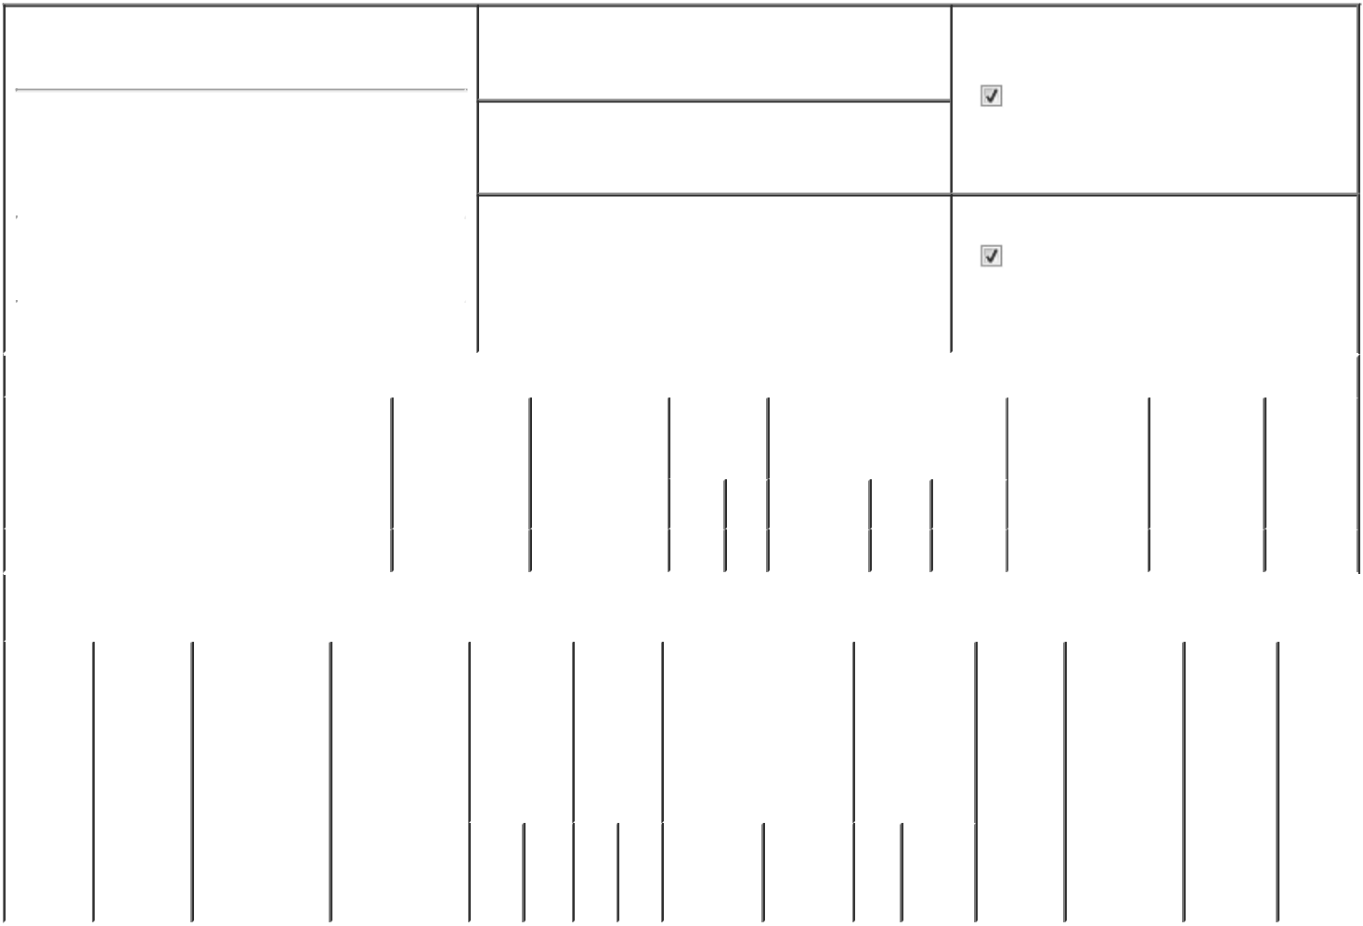

1. Name and Address of Reporting Person*
Kulhari Ruchi

(Last) (First) (Middle)

C/O UNISYS CORPORATION

801 LAKEVIEW DRIVE, SUITE 100

2. Issuer Name and Ticker or Trading Symbol

UNISYS CORP [ UIS ]

3. Date of Earliest Transaction (Month/Day/Year)

02/27/2026

- Relationship of Reporting Person(s) to Issuer (Check all applicable)

Director 10% Owner

Officer (give title Other (specify

below) below)

SVP & CHRO

 |  |  |  |  |  |  |  | 4. If Amendment, Date of Original Filed (Month/Day/Year) |  |  |  |  |  |  | 6. Individual or Joint/Group Filing (Check Applicable
 | (Street) |  |  |  |  |  |  |  |  |  |  |  |  |  | Line)
 |  |  |  |  |  |  |  |  |  |  |  |  |  |  |  |  |  | Form filed by One Reporting Person
 |  | BLUE BELL |  | PA |  | 19422
 |  |  |  | PA |  | 19422 |  |  |  |  |  |  |  |  |  |  |  | Form filed by More than One Reporting
 |  |  |  |  |  |  |  |  |  |  |  |  |  |  |  |  |  | Person
 |  | (City) |  | (State) |  | (Zip)
 |  |  |  |  | Table I - Non-Derivative Securities Acquired, Disposed of, or Beneficially Owned
 | 1. Title of Security (Instr. 3) |  |  |  |  | 2. Transaction |  |  | 2A. Deemed |  | 3. | 4. Securities Acquired (A) or |  |  |  |  |  | 5. Amount of |  | 6. Ownership | 7. Nature
 |  |  |  |  |  | Date |  |  | Execution Date, |  | Transaction | Disposed Of (D) (Instr. 3, 4 and Securities |  |  |  |  |  |  |  | Form: Direct | of Indirect
 |  |  |  |  |  | (Month/Day/Year) |  |  | if any |  | Code (Instr. | 5) |  |  |  |  |  | Beneficially |  | (D) or Indirect | Beneficial
 |  |  |  |  |  |  |  |  | (Month/Day/Year) |  | 8) |  |  |  |  |  |  | Owned Following |  | (I) (Instr. 4) | Ownership
 |  |  |  |  |  |  |  |  |  |  |  |  |  |  |  |  |  | Reported |  |  | (Instr. 4)
 |  |  |  |  |  |  |  |  |  |  | Code V | Amount | (A) or |  | Price |  |  | Transaction(s)
 |  |  |  |  |  |  |  |  |  |  | Code V | Amount | (D) |  |  |  |  | (Instr. 3 and 4)
 | Common Stock |  |  |  |  | 02/27/2026 |  |  |  |  | A | 123,457 | A |  | $0 |  | 201,189 |  |  | D
 |  |  |  |  |  | Table II - Derivative Securities Acquired, Disposed of, or Beneficially Owned
 |  |  |  |  |  | (e.g., puts, calls, warrants, options, convertible securities)
 | 1. Title of |  | 2. |  | 3. Transaction | 3A. Deemed | 4. |  |  | 5. Number | 6. Date Exercisable and |  | 7. Title and |  |  |  | 8. Price of |  | 9. Number of 10. |  | 11. Nature
 | Derivative |  | Conversion |  | Date | Execution Date, |  | Transaction |  | of | Expiration Date |  | Amount of |  |  |  | Derivative |  | derivative | Ownership | of Indirect
 | Security |  | or Exercise |  | (Month/Day/Year) if any |  |  | Code (Instr. |  | Derivative | (Month/Day/Year) |  | Securities |  |  |  | Security |  | Securities | Form: | Beneficial
 | (Instr. 3) |  | Price of |  |  | (Month/Day/Year) | 8) |  |  | Securities |  |  | Underlying |  |  |  | (Instr. 5) |  | Beneficially | Direct (D) | Ownership
 |  |  | Derivative |  |  |  |  |  |  | Acquired |  |  | Derivative |  |  |  |  |  | Owned | or Indirect | (Instr. 4)
 |  |  | Security |  |  |  |  |  |  | (A) or |  |  | Security (Instr. |  |  |  |  |  | Following | (I) (Instr. 4)
 |  |  |  |  |  |  |  |  |  | Disposed |  |  | 3 and 4) |  |  |  |  |  | Reported
 |  |  |  |  |  |  |  |  |  | of (D) |  |  |  |  |  |  |  |  | Transaction(s)
 |  |  |  |  |  |  |  |  |  | (Instr. 3, 4 |  |  |  |  |  |  |  |  | (Instr. 4)
 |  |  |  |  |  |  |  |  |  | and 5)
 |  |  |  |  |  |  |  |  |  |  |  |  |  | Amount
 |  |  |  |  |  |  |  |  |  |  |  |  |  | or
 |  |  |  |  |  |  |  |  |  |  |  |  |  | Number
 |  |  |  |  |  |  |  |  |  |  | Date | Expiration |  | of
 |  |  |  |  |  |  |  | Code | V | (A) (D) | Exercisable | Date | Title | Shares

Explanation of Responses:

/s/ Tina V. John, Attorney-in-

Fact

** Signature of Reporting Person

03/02/2026

Date

Reminder: Report on a separate line for each class of securities beneficially owned directly or indirectly.

* If the form is filed by more than one reporting person, see Instruction 4 (b)(v).

- Intentional misstatements or omissions of facts constitute Federal Criminal Violations See 18 U.S.C. 1001 and 15 U.S.C. 78ff(a). Note: File three copies of this Form, one of which must be manually signed. If space is insufficient, see Instruction 6 for procedure.

Persons who respond to the collection of information contained in this form are not required to respond unless the form displays a currently valid OMB Number.

Exhibit 24.1
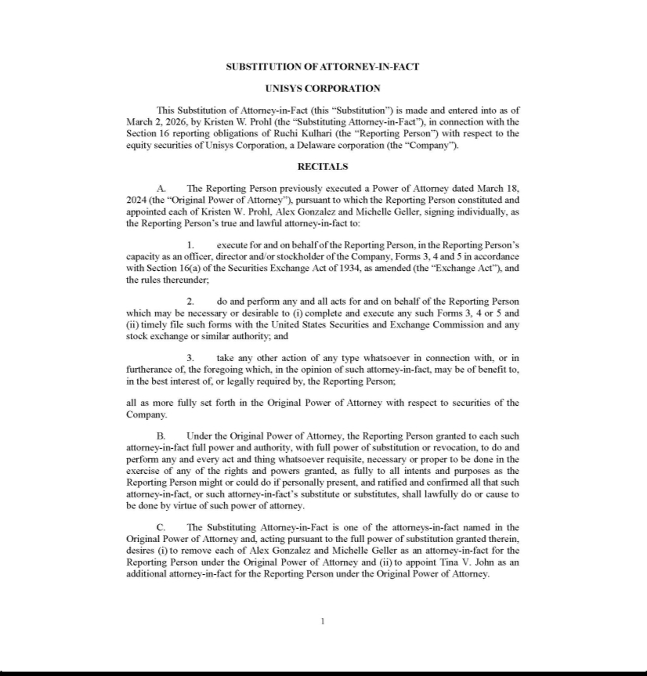

Exhibit 24.2
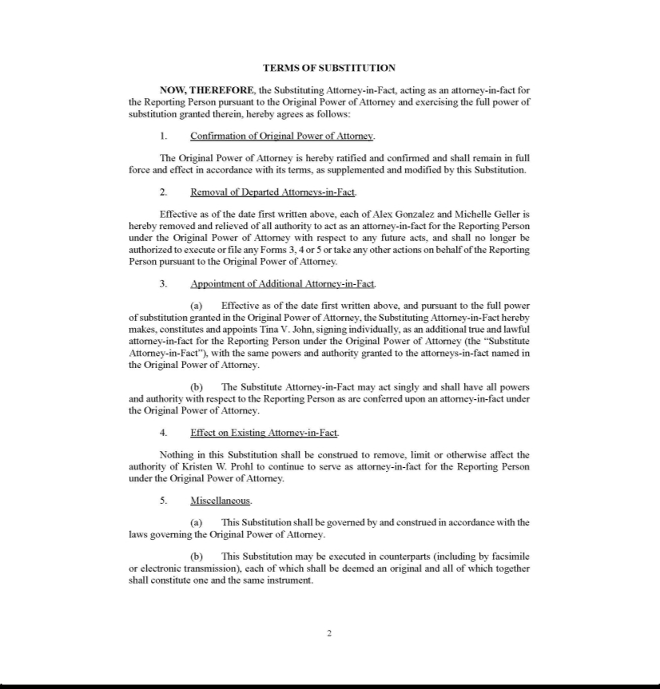

Exhibit 24.3


