UNITED STATES
SECURITIES AND EXCHANGE COMMISSION
Washington, D.C. 20549
SCHEDULE 14A
Proxy Statement Pursuant to Section 14(a) of the
Securities Exchange Act of 1934 (Amendment No. )

☒ Filed by the Registrant |  |  |  |  |  | ☐ Filed by a Party other than the Registrant
CHECK THE APPROPRIATE BOX:
☐ Preliminary Proxy Statement
☐ Confidential, for Use of the Commission Only (as permitted by Rule 14a-6(e)(2))
☐ Definitive Proxy Statement
☒ Definitive Additional Materials
☐ Soliciting Material Pursuant to §240.14a-12
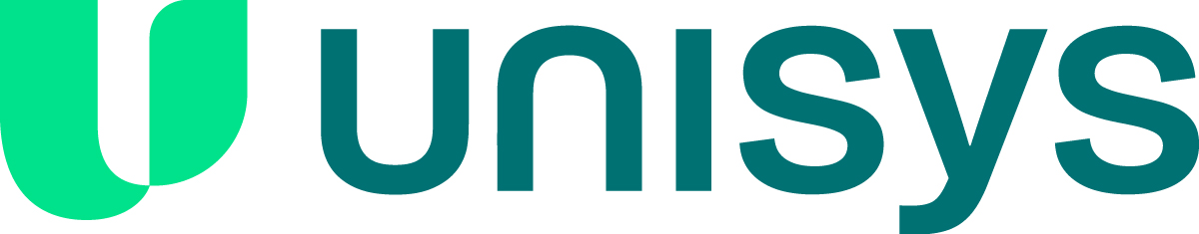
Unisys Corporation
(Name of Registrant as Specified in its Charter)
(Name of Person(s) Filing Proxy Statement, if other than the Registrant)
PAYMENT OF FILING FEE (CHECK ALL BOXES THAT APPLY):
☒ No fee required
☐ Fees paid previously with preliminary materials
☐ Fee computed on table in exhibit required by Item 25(b) per Exchange Act Rules 14a-6(i)(1) and 0-11



